LAB EXPERIMENT RECORD

Department | AIDS
Course Code / Course Name | DSA0601 / Data Handling and Visualization
Experiment | Data Visualization using R
Name | B. Pallavi
Register Number | 192424243
Date | 17 October 2026
Day | Saturday

AIM
To analyze employee performance, department-wise employee counts, and the relationship between years of service and performance scores using R.
DATASET
Employee ID | Department | Years of Service | Performance Score
1 | Sales | 5 | 85
2 | HR | 3 | 92
3 | Marketing | 7 | 78
4 | Sales | 4 | 90
5 | HR | 2 | 76
PROGRAM 1: DEPARTMENT-WISE EMPLOYEE COUNT
Code:
department <- c("Sales","HR","Marketing","Sales","HR")
barplot(table(department),
col="skyblue",
main="Employees by Department",
xlab="Department",
ylab="Number of Employees")
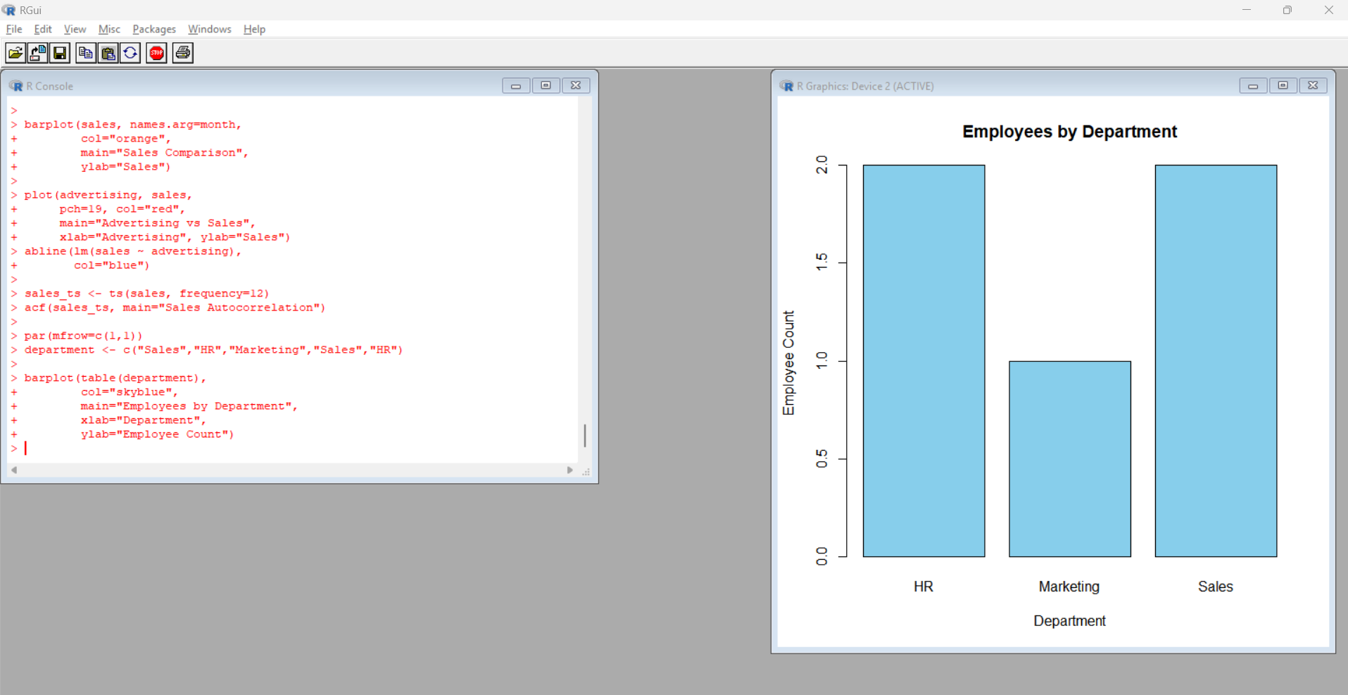
Output: A bar chart displaying the number of employees in each department.
Observation: Sales and HR have two employees each, while Marketing has one employee.
PROGRAM 2: PERFORMANCE SCORE ANALYSIS
Code:
years <- c(5,3,7,4,2)
score <- c(85,92,78,90,76)
plot(years, score,
type="b", pch=19,
col="blue",
main="Years of Service vs Performance",
xlab="Years of Service",
ylab="Performance Score")
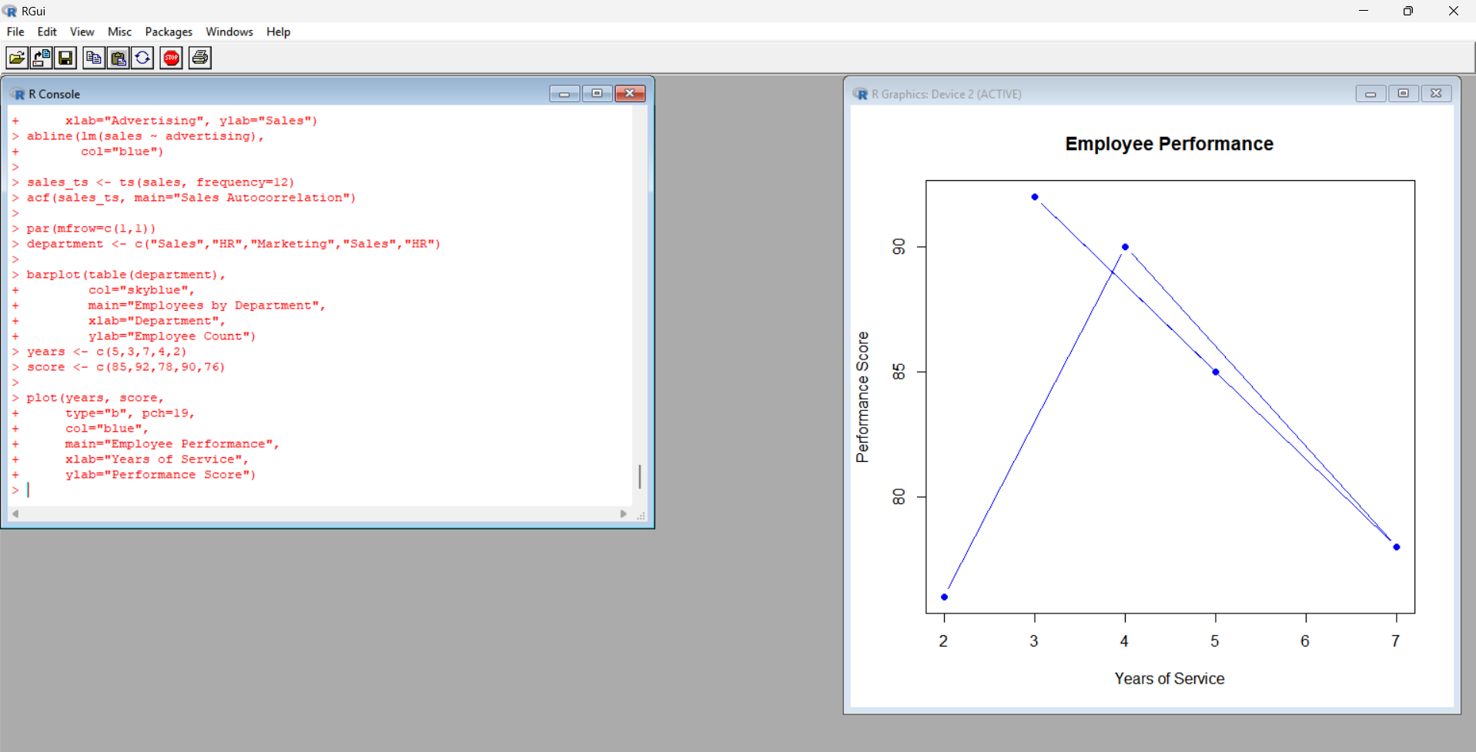
Output: A plot showing years of service against performance scores.
Observation: The highest performance score is 92, achieved by an employee with three years of service. The small dataset does not establish a general relationship.
PROGRAM 3: EMPLOYEE DATA TABLE
Code:
employee <- data.frame(
ID=1:5,
Department=c("Sales","HR","Marketing","Sales","HR"),
Years=c(5,3,7,4,2),
Score=c(85,92,78,90,76)
)
print(employee)
print(mean(employee$Score))
print(max(employee$Score))
c 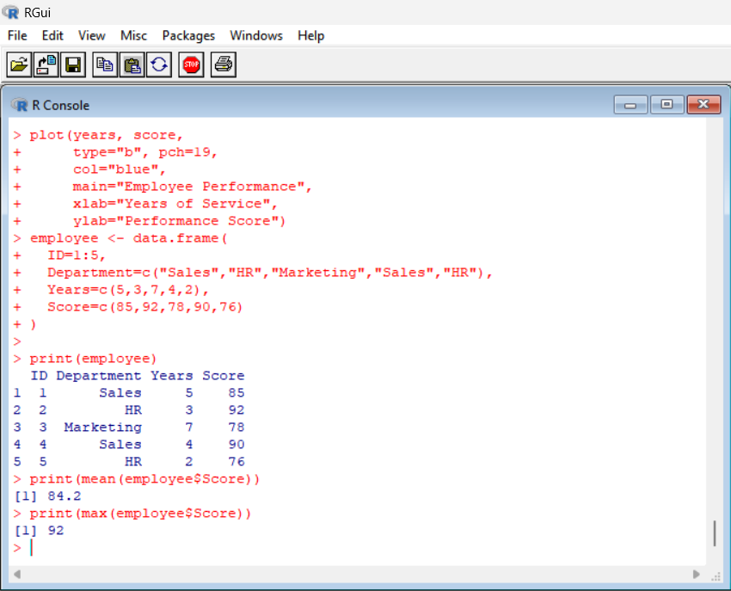
Output:
- Average performance score: 84.2
- Highest performance score: 92
Observation: The average employee performance score is 84.2.
PROGRAM 4: EMPLOYEE PERFORMANCE DASHBOARD
Code:
department <- c("Sales","HR","Marketing","Sales","HR")
years <- c(5,3,7,4,2)
score <- c(85,92,78,90,76)
par(mfrow=c(2,2))
barplot(table(department),
col="skyblue",
main="Department Count",
xlab="Department", ylab="Employees")
plot(years, score,
pch=19, col="red",
main="Service vs Performance",
xlab="Years of Service",
ylab="Score")

barplot(score, names.arg=1:5,
col="orange",
main="Employee Scores",
xlab="Employee ID", ylab="Score")
hist(score,
col="lightgreen",
main="Performance Distribution",
xlab="Performance Score")
par(mfrow=c(1,1))
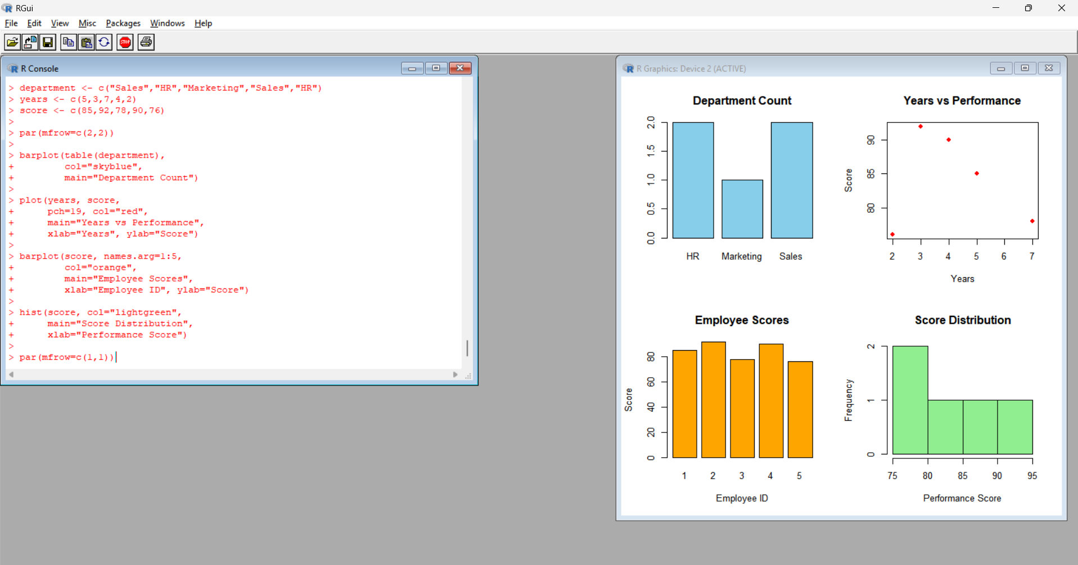
Output: A four-panel dashboard showing department counts, service versus performance, individual employee scores, and score distribution.
Observation: The dashboard summarizes employee distribution and performance scores.
RESULT
Employee performance data were analyzed using bar charts, scatter plots, histograms, and summary statistics in R.

